library(data.table)  
main_dir = "/Users/victorpokorny/Library/CloudStorage/GoogleDrive-vpokorny123@gmail.com/My Drive/CAPR Ebbinghaus and Mooney/"  
source(paste0(main_dir,'R_scripts/funcs.R')) # big group of functions  
load(file=paste0(main_dir,"RData/cleaned.RData")) #read in the data

#context sensitivity and cognition  
#let's look at bivariate associations first  
perception_variables = c('context_sensitivity_all_trials')   
cognition_variables = c('bacs_total', 'hvlt_total_score','wrat_standardscore')  
p_vals = NULL  
combo_names = NULL  
for (j in perception_variables){  
 for (jj in cognition_variables){  
 res = cor.test(main_df[[j]], main_df[[jj]])  
 combo_name = paste(j,jj)  
 combo_names = rbind(combo_names,combo_name)  
 print(combo_name)  
 print(pub_ready_stats(res))  
 p_val = res$p.value  
 p_vals = rbind(p_vals,p_val)  
 }  
}

## [1] "context_sensitivity_all_trials bacs_total"  
## [1] "r(572)=0.13, p=0.002"  
## [1] "context_sensitivity_all_trials hvlt_total_score"  
## [1] "r(608)=0.1, p=0.011"  
## [1] "context_sensitivity_all_trials wrat_standardscore"  
## [1] "r(550)=0.09, p=0.038"

cbind(unname(combo_names), round(p.adjust(p_vals, 'fdr'),3))

## [,1] [,2]   
## [1,] "context_sensitivity_all_trials bacs_total" "0.007"  
## [2,] "context_sensitivity_all_trials hvlt_total_score" "0.016"  
## [3,] "context_sensitivity_all_trials wrat_standardscore" "0.038"

#then multivariate prediction  
pub_ready_stats(lm(context_sensitivity_all_trials ~ wrat_standardscore + bacs_total + hvlt_total_score, main_df))

## See details in:

## Carlos Cinelli and Chad Hazlett (2020). Making Sense of Sensitivity: Extending Omitted Variable Bias. Journal of the Royal Statistical Society, Series B (Statistical Methodology).

## [,1] [,2]   
## [1,] "(Intercept)" "b=28.418, t(480)=3.11, p<.001, partial r^2 = 0.02"  
## [2,] "wrat_standardscore" "b=0.059, t(480)=0.77, p=0.44, partial r^2 = 0.001"  
## [3,] "bacs_total" "b=0.181, t(480)=2.03, p=0.04, partial r^2 = 0.009"  
## [4,] "hvlt_total_score" "b=0.36, t(480)=1.4, p=0.16, partial r^2 = 0.004"

#context sensitivity and social/role  
cognition_variables = c('gfs_current', 'gfr_current','sps_total')  
p_vals = NULL  
combo_names = NULL  
for (j in perception_variables){  
 for (jj in cognition_variables){  
 res = cor.test(main_df[[j]], main_df[[jj]])  
 combo_name = paste(j,jj)  
 combo_names = rbind(combo_names,combo_name)  
 print(combo_name)  
 print(pub_ready_stats(res))  
 p_val = res$p.value  
 p_vals = rbind(p_vals,p_val)  
 }  
}

## [1] "context_sensitivity_all_trials gfs_current"  
## [1] "r(640)=0.05, p=0.232"  
## [1] "context_sensitivity_all_trials gfr_current"  
## [1] "r(642)=0.06, p=0.141"  
## [1] "context_sensitivity_all_trials sps_total"  
## [1] "r(622)=-0.06, p=0.146"

cbind(unname(combo_names), round(p.adjust(p_vals, 'fdr'),3))

## [,1] [,2]   
## [1,] "context_sensitivity_all_trials gfs_current" "0.232"  
## [2,] "context_sensitivity_all_trials gfr_current" "0.219"  
## [3,] "context_sensitivity_all_trials sps_total" "0.219"

#let's look at bivariate associations with Mooney  
mooney_variables = c('inverted_faces_reported')  
cognition_variables = c('bacs_total', 'wrat_standardscore','hvlt_total_score')  
p_vals = NULL  
combo_names = NULL  
for (j in mooney_variables){  
 for (jj in cognition_variables){  
 res = cor.test(main_df[[j]], main_df[[jj]])  
 combo_name = paste(j,jj)  
 combo_names = rbind(combo_names,combo_name)  
 print(combo_name)  
 print(pub_ready_stats(res))  
 p_val = res$p.value  
 p_vals = rbind(p_vals,p_val)  
 }  
}

## [1] "inverted_faces_reported bacs_total"  
## [1] "r(567)=-0.06, p=0.155"  
## [1] "inverted_faces_reported wrat_standardscore"  
## [1] "r(551)=0.02, p=0.671"  
## [1] "inverted_faces_reported hvlt_total_score"  
## [1] "r(609)=0, p=0.931"

cbind(unname(combo_names), round(p.adjust(p_vals, 'fdr'),3))

## [,1] [,2]   
## [1,] "inverted_faces_reported bacs_total" "0.466"  
## [2,] "inverted_faces_reported wrat_standardscore" "0.931"  
## [3,] "inverted_faces_reported hvlt_total_score" "0.931"

cognition_variables = c('gfs_current', 'gfr_current','sps_total')  
p_vals = NULL  
combo_names = NULL  
for (j in mooney_variables){  
 for (jj in cognition_variables){  
 res = cor.test(main_df[[j]], main_df[[jj]])  
 combo_name = paste(j,jj)  
 combo_names = rbind(combo_names,combo_name)  
 print(combo_name)  
 print(pub_ready_stats(res))  
 p_val = res$p.value  
 p_vals = rbind(p_vals,p_val)  
 }  
}

## [1] "inverted_faces_reported gfs_current"  
## [1] "r(636)=-0.09, p=0.025"  
## [1] "inverted_faces_reported gfr_current"  
## [1] "r(638)=-0.16, p<.001"  
## [1] "inverted_faces_reported sps_total"  
## [1] "r(616)=0.14, p<.001"

cbind(unname(combo_names), round(p.adjust(p_vals, 'fdr'),3))

## [,1] [,2]   
## [1,] "inverted_faces_reported gfs_current" "0.025"  
## [2,] "inverted_faces_reported gfr_current" "0"   
## [3,] "inverted_faces_reported sps_total" "0.001"

pub_ready_stats(lm(inverted_faces_reported ~ gfs_current+gfr_current+sps_total, main_df))

## [,1] [,2]   
## [1,] "(Intercept)" "b=18.97, t(606)=6.52, p<.001, partial r^2 = 0.066"   
## [2,] "gfs_current" "b=0.106, t(606)=0.31, p=0.75, partial r^2 = 0"   
## [3,] "gfr_current" "b=-0.881, t(606)=-3.24, p<.001, partial r^2 = 0.017"  
## [4,] "sps_total" "b=0.053, t(606)=2.21, p=0.03, partial r^2 = 0.008"

#cognitive functioning  
print("Mooney Faces and Cognitive Variables")

## [1] "Mooney Faces and Cognitive Variables"

summary(lm(upright_faces_reported ~ wrat_standardscore + bacs_total + hvlt_total_score, main_df))

##   
## Call:  
## lm(formula = upright_faces_reported ~ wrat_standardscore + bacs_total +   
## hvlt_total_score, data = main_df)  
##   
## Residuals:  
## Min 1Q Median 3Q Max   
## -31.958 -3.476 1.093 4.112 10.202   
##   
## Coefficients:  
## Estimate Std. Error t value Pr(>|t|)   
## (Intercept) 28.148327 2.268933 12.406 <2e-16 ***  
## wrat_standardscore 0.031713 0.019709 1.609 0.108   
## bacs_total 0.009195 0.022366 0.411 0.681   
## hvlt_total_score 0.049321 0.063934 0.771 0.441   
## ---  
## Signif. codes: 0 '***' 0.001 '**' 0.01 '*' 0.05 '.' 0.1 ' ' 1  
##   
## Residual standard error: 5.786 on 477 degrees of freedom  
## (329 observations deleted due to missingness)  
## Multiple R-squared: 0.01177, Adjusted R-squared: 0.005551   
## F-statistic: 1.893 on 3 and 477 DF, p-value: 0.1298

summary(lm(inverted_faces_reported ~ wrat_standardscore + bacs_total + hvlt_total_score, main_df))

##   
## Call:  
## lm(formula = inverted_faces_reported ~ wrat_standardscore + bacs_total +   
## hvlt_total_score, data = main_df)  
##   
## Residuals:  
## Min 1Q Median 3Q Max   
## -14.357 -7.812 -1.440 6.377 29.168   
##   
## Coefficients:  
## Estimate Std. Error t value Pr(>|t|)   
## (Intercept) 15.662732 3.703218 4.229 2.81e-05 ***  
## wrat_standardscore 0.008194 0.032089 0.255 0.799   
## bacs_total -0.045711 0.036436 -1.255 0.210   
## hvlt_total_score -0.001834 0.104418 -0.018 0.986   
## ---  
## Signif. codes: 0 '***' 0.001 '**' 0.01 '*' 0.05 '.' 0.1 ' ' 1  
##   
## Residual standard error: 9.452 on 479 degrees of freedom  
## (327 observations deleted due to missingness)  
## Multiple R-squared: 0.003851, Adjusted R-squared: -0.002388   
## F-statistic: 0.6173 on 3 and 479 DF, p-value: 0.6041

library(afex)

## Loading required package: lme4

## Loading required package: Matrix

## ************  
## Welcome to afex. For support visit: http://afex.singmann.science/

## - Functions for ANOVAs: aov_car(), aov_ez(), and aov_4()  
## - Methods for calculating p-values with mixed(): 'S', 'KR', 'LRT', and 'PB'  
## - 'afex_aov' and 'mixed' objects can be passed to emmeans() for follow-up tests  
## - Get and set global package options with: afex_options()  
## - Set sum-to-zero contrasts globally: set_sum_contrasts()  
## - For example analyses see: browseVignettes("afex")  
## ************

##   
## Attaching package: 'afex'

## The following object is masked from 'package:lme4':  
##   
## lmer

library(tidyr)

##   
## Attaching package: 'tidyr'

## The following objects are masked from 'package:Matrix':  
##   
## expand, pack, unpack

library(ggplot2)  
library(dplyr)

##   
## Attaching package: 'dplyr'

## The following objects are masked from 'package:data.table':  
##   
## between, first, last

## The following objects are masked from 'package:stats':  
##   
## filter, lag

## The following objects are masked from 'package:base':  
##   
## intersect, setdiff, setequal, union

#-----------Ebbinghaus group differences-----  
pub_ready_stats(anova(lm(context_sensitivity_all_trials ~ phenotype_final, main_df)))

## [1] "F(3,645)=0.99, p=0.395"

posthoc_groups = unique(main_df$phenotype_final)  
contrasts = list(c(1,2),c(1,3),c(1,4))  
post_hoc_res <- NULL  
for (j in contrasts ){  
 group1 = posthoc_groups[j][1]  
 group2 = posthoc_groups[j][2]  
 res<- t.test(main_df$context_sensitivity_all_trials[main_df$phenotype_final==group1],  
 main_df$context_sensitivity_all_trials[main_df$phenotype_final==group2],  
 var.equal=TRUE)  
 print(as.character(c(group1,group2)))  
 print(pub_ready_stats(res))  
}

## [1] "hc" "hsc_sub"  
## [1] "t(299)=1.67, p=0.096, Cohen's d=0.1"  
## [1] "hc" "hsc_other"  
## [1] "t(259)=0.88, p=0.379, Cohen's d=0.05"  
## [1] "hc" "chr"  
## [1] "t(433)=0.91, p=0.364, Cohen's d=0.04"

#----- Mooney group differences -------  
main_df_long <- pivot_longer(main_df, cols = c('inverted_faces_reported',  
 'upright_faces_reported'),   
 names_to = 'condition',   
 values_to = 'responses')  
res <- aov_ez(data = main_df_long, dv = 'responses', within = 'condition',  
 between = 'phenotype_final', id = 'src_subject_id')

## Warning: Missing values for 166 ID(s), which were removed before analysis:  
## 10005, 10007, 10014, 10027, 10034, 10039, 10040, 10045, 10047, 10049, ... [showing first 10 only]  
## Below the first few rows (in wide format) of the removed cases with missing data.  
## src_subject_id phenotype_final inverted_faces_reported upright_faces_reported  
## # 1 10005 hc NA NA  
## # 2 10007 hc NA NA  
## # 3 10014 hsc_sub NA NA  
## # 4 10027 hsc_other NA NA  
## # 5 10034 hsc_other NA NA  
## # 6 10039 chr NA NA

## Contrasts set to contr.sum for the following variables: phenotype_final

pub_ready_stats(res)

## [,1] [,2]   
## [1,] "phenotype_final" "F(3,640)=6.37, p<.001, η²=.029"   
## [2,] "condition" "F(1,640)=4981.39, p<.001, η²=.886"  
## [3,] "phenotype_final:condition" "F(3,640)=9.49, p<.001, η²=.043"

post_hoc_res <- NULL  
for (j in contrasts ){  
 group1 = posthoc_groups[j][1]  
 group2 = posthoc_groups[j][2]  
 res<- t.test(main_df$`Inverted Faces Reported`[main_df$phenotype_final==group1],  
 main_df$`Inverted Faces Reported`[main_df$phenotype_final==group2],var.equal=TRUE)  
 print(paste(as.character(c(group1,group2)),'inverted faces'))  
 print(pub_ready_stats(res))  
   
 res<- t.test(main_df$`Upright Faces Reported`[main_df$phenotype_final==group1],  
 main_df$`Upright Faces Reported`[main_df$phenotype_final==group2],var.equal=TRUE)  
 print(paste(as.character(c(group1,group2)),'upright faces'))  
 print(pub_ready_stats(res))  
}

## [1] "hc inverted faces" "hsc_sub inverted faces"  
## [1] "t(289)=-0.31, p=0.753, Cohen's d=-0.02"  
## [1] "hc upright faces" "hsc_sub upright faces"  
## [1] "t(289)=-0.81, p=0.419, Cohen's d=-0.05"  
## [1] "hc inverted faces" "hsc_other inverted faces"  
## [1] "t(250)=0.45, p=0.654, Cohen's d=0.03"  
## [1] "hc upright faces" "hsc_other upright faces"  
## [1] "t(250)=-0.3, p=0.763, Cohen's d=-0.02"  
## [1] "hc inverted faces" "chr inverted faces"  
## [1] "t(427)=-4.02, p<.001, Cohen's d=-0.19"  
## [1] "hc upright faces" "chr upright faces"  
## [1] "t(425)=-1.95, p=0.052, Cohen's d=-0.09"

#plot  
plot_groups(main_df_long, quo(phenotype_final))

## `summarise()` has grouped output by 'phenotype_final'. You can override using  
## the `.groups` argument.

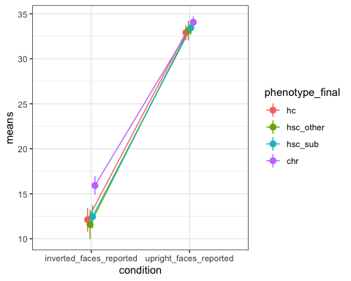

# test whether correlations are significantly different for social vs. cognitive  
  
y = 'context_sensitivity_all_trials'  
X1 = c('bacs_total','hvlt_total_score','wrat_standardscore')  
X2 = c('gfr_current', 'gfs_current','sps_total')  
Xy_vars = c(y,X1,X2)  
cocor_df<- main_df[,Xy_vars, with = FALSE]  
cocor_df_complete<- cocor_df[complete.cases(cocor_df),]  
j<- unlist(cocor_df_complete[,y, with = FALSE])  
k_fac_res<- unifactorScores(cocor_df_complete[,X1, with = FALSE])  
k <- k_fac_res$scores  
print(k_fac_res$FSI)

## FI  
## f1 0.7956424

h_fac_res<- unifactorScores(cocor_df_complete[,X2, with = FALSE])  
h <- h_fac_res$scores  
print(h_fac_res$FSI)

## FI  
## f1 0.8218136

run.cocor.dep.groups.overlap(j, k, h)

##   
## Results of a comparison of two overlapping correlations based on dependent groups  
##   
## Comparison between r.jk = -0.156 and r.jh = 0.0639  
## Difference: r.jk - r.jh = -0.2199  
## Related correlation: r.kh = -0.2852  
## Group size: n = 462  
## Null hypothesis: r.jk is equal to r.jh  
## Alternative hypothesis: r.jk is not equal to r.jh (two-sided)  
## Alpha: 0.05  
##   
## pearson1898: Pearson and Filon's z (1898)  
## z = -2.9961, p-value = 0.0027  
## Null hypothesis rejected  
##   
## hotelling1940: Hotelling's t (1940)  
## t = -2.9758, df = 459, p-value = 0.0031  
## Null hypothesis rejected  
##   
## williams1959: Williams' t (1959)  
## t = -2.9721, df = 459, p-value = 0.0031  
## Null hypothesis rejected  
##   
## olkin1967: Olkin's z (1967)  
## z = -2.9961, p-value = 0.0027  
## Null hypothesis rejected  
##   
## dunn1969: Dunn and Clark's z (1969)  
## z = -2.9624, p-value = 0.0031  
## Null hypothesis rejected  
##   
## hendrickson1970: Hendrickson, Stanley, and Hills' (1970) modification of Williams' t (1959)  
## t = -2.9758, df = 459, p-value = 0.0031  
## Null hypothesis rejected  
##   
## steiger1980: Steiger's (1980) modification of Dunn and Clark's z (1969) using average correlations  
## z = -2.9560, p-value = 0.0031  
## Null hypothesis rejected  
##   
## meng1992: Meng, Rosenthal, and Rubin's z (1992)  
## z = -2.9497, p-value = 0.0032  
## Null hypothesis rejected  
## 95% confidence interval for r.jk - r.jh: -0.3683 -0.0742  
## Null hypothesis rejected (Interval does not include 0)  
##   
## hittner2003: Hittner, May, and Silver's (2003) modification of Dunn and Clark's z (1969) using a backtransformed average Fisher's (1921) Z procedure  
## z = -2.9559, p-value = 0.0031  
## Null hypothesis rejected  
##   
## zou2007: Zou's (2007) confidence interval  
## 95% confidence interval for r.jk - r.jh: -0.3624 -0.0745  
## Null hypothesis rejected (Interval does not include 0)

pub_ready_stats(cor.test(j,k)) #context sensitivity and cognition

## [1] "r(460)=-0.16, p=0.001"

pub_ready_stats(cor.test(j,h))#context sensitivity and social/role

## [1] "r(460)=0.06, p=0.17"

scatterplot(j,k)

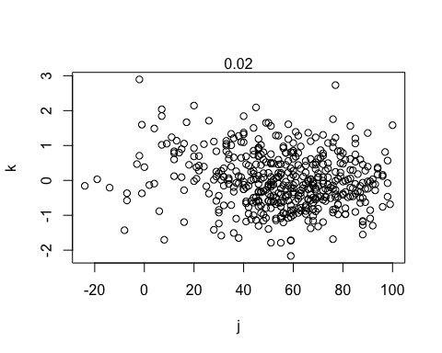

scatterplot(j,h)

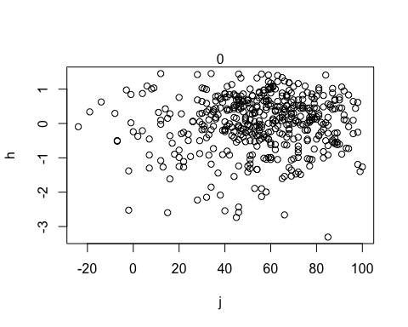

y = 'inverted_faces_reported'  
X1 = c('bacs_total','hvlt_total_score','wrat_standardscore')  
X2 = c('gfr_current', 'gfs_current','sps_total')  
Xy_vars = c(y,X1,X2)  
cocor_df<- main_df[,Xy_vars, with = FALSE]  
cocor_df_complete<- cocor_df[complete.cases(cocor_df),]  
j<- unlist(cocor_df_complete[,y, with = FALSE])  
k_fac_res<- unifactorScores(cocor_df_complete[,X1, with = FALSE])  
k <- k_fac_res$scores  
print(k_fac_res$FSI)

## FI  
## f1 0.8087258

h_fac_res<- unifactorScores(cocor_df_complete[,X2, with = FALSE])  
h <- h_fac_res$scores  
print(h_fac_res$FSI)

## FI  
## f1 0.8191782

run.cocor.dep.groups.overlap(j, k, h)

##   
## Results of a comparison of two overlapping correlations based on dependent groups  
##   
## Comparison between r.jk = -0.026 and r.jh = 0.1631  
## Difference: r.jk - r.jh = -0.1891  
## Related correlation: r.kh = -0.2943  
## Group size: n = 458  
## Null hypothesis: r.jk is equal to r.jh  
## Alternative hypothesis: r.jk is not equal to r.jh (two-sided)  
## Alpha: 0.05  
##   
## pearson1898: Pearson and Filon's z (1898)  
## z = -2.5522, p-value = 0.0107  
## Null hypothesis rejected  
##   
## hotelling1940: Hotelling's t (1940)  
## t = -2.5421, df = 455, p-value = 0.0113  
## Null hypothesis rejected  
##   
## williams1959: Williams' t (1959)  
## t = -2.5349, df = 455, p-value = 0.0116  
## Null hypothesis rejected  
##   
## olkin1967: Olkin's z (1967)  
## z = -2.5522, p-value = 0.0107  
## Null hypothesis rejected  
##   
## dunn1969: Dunn and Clark's z (1969)  
## z = -2.5289, p-value = 0.0114  
## Null hypothesis rejected  
##   
## hendrickson1970: Hendrickson, Stanley, and Hills' (1970) modification of Williams' t (1959)  
## t = -2.5421, df = 455, p-value = 0.0113  
## Null hypothesis rejected  
##   
## steiger1980: Steiger's (1980) modification of Dunn and Clark's z (1969) using average correlations  
## z = -2.5249, p-value = 0.0116  
## Null hypothesis rejected  
##   
## meng1992: Meng, Rosenthal, and Rubin's z (1992)  
## z = -2.5210, p-value = 0.0117  
## Null hypothesis rejected  
## 95% confidence interval for r.jk - r.jh: -0.3388 -0.0424  
## Null hypothesis rejected (Interval does not include 0)  
##   
## hittner2003: Hittner, May, and Silver's (2003) modification of Dunn and Clark's z (1969) using a backtransformed average Fisher's (1921) Z procedure  
## z = -2.5249, p-value = 0.0116  
## Null hypothesis rejected  
##   
## zou2007: Zou's (2007) confidence interval  
## 95% confidence interval for r.jk - r.jh: -0.3332 -0.0426  
## Null hypothesis rejected (Interval does not include 0)

pub_ready_stats(cor.test(j,k)) #inverted mooney face and cognition

## [1] "r(456)=-0.03, p=0.579"

pub_ready_stats(cor.test(j,h))#inverted mooner face and social/role

## [1] "r(456)=0.16, p<.001"

scatterplot(j,k)

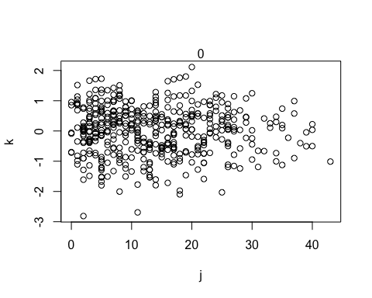

scatterplot(j,h)

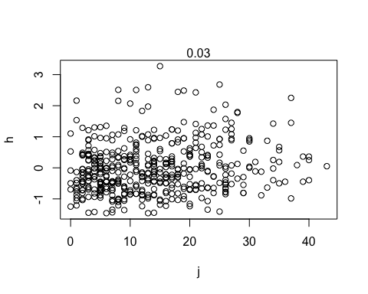

Ok so story so far is that treating cognition and social/role functioning as latent variables and grabbing factor scores we get a significant difference in correlations

#does context sensitivity correlate with inverted face detection  
pub_ready_stats(cor.test(main_df$context_sensitivity_all_trials,main_df$inverted_faces_reported))

## [1] "r(600)=0, p=0.932"

pub_ready_stats(cor.test(main_df$context_sensitivity_all_trials,main_df$upright_faces_reported))

## [1] "r(598)=0.03, p=0.529"